Class Imbalance Problem
Data Level Approach
Algorithm Level Approach
Hybrid Approach
Sampling
Feature Selection
Cost Sensitive Methods
One class Learners
Ensemble Learning

- Data Level Approach
Modify training data to balance the classes
  - Sampling Methods

Category | Methods | Description
Random Sampling | Random Undersampling, Random Oversampling | Reduces or increases samples without adding new information
Heuristic Oversampling | SMOTE (Synthetic Minority Oversampling Technique) | Generates new minority samples by interpolation
 | Borderline-SMOTE, SMOTE-Tomek Links, SMOTE-ENN | Improves SMOTE with noise removal or focusing on boundary samples
Advanced Oversampling | ADASYN (Adaptive Synthetic Sampling) | Creates more synthetic points where imbalance is higher
 | KMeans-SMOTE, Gaussian Noise Perturbation, MixUp-based Oversampling | Uses clustering or smooth feature mixing to avoid overfitting
Advanced Undersampling | NearMiss, Clustering-based Undersampling, Instance Hardness Threshold | Removes easily classified majority samples to retain informative ones

  - Feature Selection Methods

Method | Description
Variance Thresholding | Eliminates low-information features
Mutual Information / Chi-Square | Keeps features highly correlated with class labels
Recursive Feature Elimination (RFE) | Iteratively removes least important features
L1 Regularization (Lasso) | Forces unimportant features to zero
ReliefF / Boruta | Detects relevant features under imbalance and noise

- Algorithm Level Approach
They modify the model Training to treat minority classes more seriously
  - Cost sensitive Methods

Method | Description
Class Weighting in Loss  ( class_weight='balanced') | Penalizes misclassification of minority more strongly
Focal Loss | Focuses training on hard-to-classify samples
Cost-Sensitive SVM / Decision Trees | Uses penalty matrix for errors
Weighted Cross Entropy, Dice Loss | Common in medical / segmentation tasks

  - One class learners/ Anomaly based learners
Used when minority classes are extremely rare

Method | Description
One-Class SVM | Learns only minority class boundary
Isolation Forest | Detects anomalies relative to majority patterns
Local Outlier Factor (LOF) | Density-based rare event detection
Autoencoders (Reconstruction Error) | Learn normal patterns; deviations → minority class

- Hybrid Approach
  - Ensemble Learning

Method | Explanation
Balanced Bagging / EasyEnsemble | Train multiple models on balanced subsets via undersampling
SMOTE + Boosting (;SMOTEBoost, RUSBoost) | Oversampling applied inside boosting rounds
Balanced Random Forest | Each tree uses a balanced sample
XGBoost / LightGBM with Scale_Pos_Weight | Built-in handling of imbalance

  - Dynamic and Online Hybrid Methods

Method | Description
Dynamic Ensemble Selection for Minority | Select models focusing on difficult regions
Meta-Learning Based Resampling | Learns which samples to oversample intelligently

Papers:

Paper | Year | Link
Boosting Minority Class Prediction on Imbalanced Point Cloud Data | 2020 | https://www.mdpi.com/2076-3417/10/3/973
Subspace Prototype Guidance for Mitigating Class Imbalance in Point Cloud Semantic Segmentation | 2024 | https://link.springer.com/chapter/10.1007/978-3-031-72967-6_15
Class-imbalanced semi-supervised learning for large-scale point cloud semantic segmentation via decoupling optimization | 2024 | https://doi.org/10.1016/j.patcog.2024.110701
Subclassified Loss: Rethinking Data Imbalance From Subclass Perspective for Semantic Segmentation | 2024 | https://ieeexplore.ieee.org/stamp/stamp.jsp?tp=&arnumber=10288283

Sparse Input (N x (3 +f))
↓
Feature Encoder (DGCNN)
↓
Class-Aware Attention Module (Subclassified Loss)
↓
Upsampling Module (PU-GAN feature expansion)
↓
Dense Output (rN points/class-balanced spatial distribution)

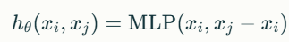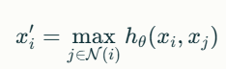
Nx(3+f)
Find k-NN
local neighborhood graph for each point
EdgeConvulation

Feature Aggreation

Final Feature Graph
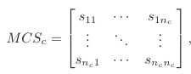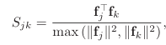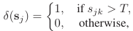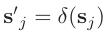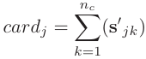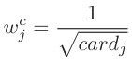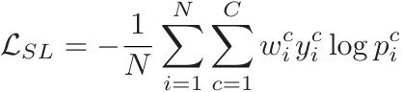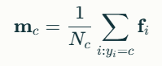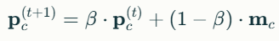
Initialize prototype vector
Final Feature Graph
Compute MCS
N=WxH
Cth class with n_{c} pixels

Class-Aware weighting
Class-Aware weighting
Subclassified Loss
Momentum Update
Trained Model

